1. **Is it possible for a country to cut emissions and also boost growth?**

Balancing economic growth with environmental protection can seem like squaring a circle, as The World Bank has noted that greater economic activity inevitably hurt the environment. However, the impossible must be attempted as economists agree economic growth is the only feasible means to eradicate poverty. The Environmental Kuznets Curve illustrates how economic growth eventually has a diminishing effect on environmental degradation, but its assumptions for a turning point are not yet properly reflected outside of theory. While the model has some empirical standing, its predictions do not hold to the extent needed to combat climate change. This paper will discuss the question of the feasibility of cutting emissions while boosting growth.

Panayotou (1992) argued for the possible diminishing effect of economic growth on environmental degradation that was later modelled as the Environmental Kuznets Curve. By graphing emissions per capita against GDP per capita, Kuznets illustrated how sufficient economic growth would decrease emissions at a turning point from an inverse U-shaped curve as shown in figure 1.

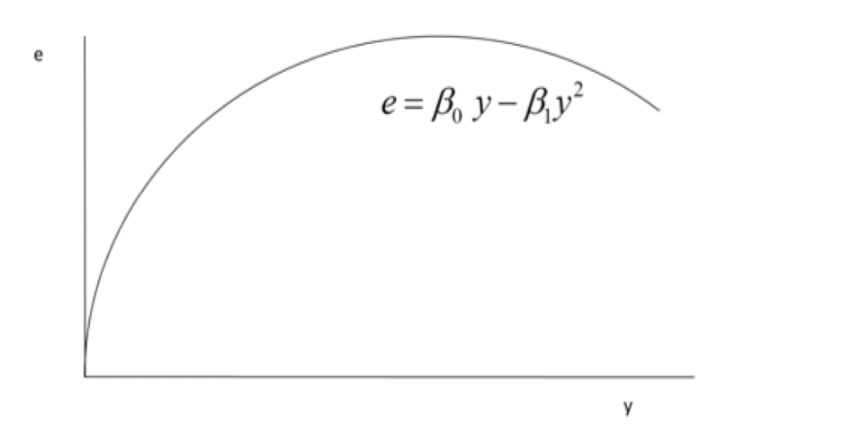

Figure 1 - Environmental Kuznets Curve (From Lecture 9, p.19)

The turning point is characterised as a stage of economic development where economic growth is structurally changed towards a service focused economy with increased environmental awareness, enforcement of environmental regulations, better technology, and higher environmental expenditures. This turning point has some empirical standing, yet it does not necessarily imply that growth is good for the environment. While Panyotou presented in 1993 empirical data that $3000 per capita was enough to bring about a turning point for sulphur dioxide (SO2), Shafik and Bandyopadhyay showed that there was no turning point for carbon dioxide (CO2). Thus, the model holds for some environmental areas but not all. Economic growth through increased gross national product is therefore not substitutable to direct environmental policies.

Additionally, countries with post-industrial economies still do not exert the traits the EKC model argues should be present. This pitfall comes from economic stage not being an accurate representation as population affluence is not reflected. Thus, a country in a later economic stage may still have a financially deficient population.

Focusing on one’s own environmental impact is a luxury not afforded by the poor. Most of the economic growth of the United States of America is tied to services, as is predicted to happen when a country reaches a post-industrial economy, yet the U.S. also has a heavily skewed income distribution. The US should theoretically be at the stage of the EKC that is downwards sloping but their abundance of poverty halts this. One understands that the goal should not only be to grow economically as a nation but to implement sustainable programs that allow for continually rising living standards, such that the population can afford the luxury of focusing on preventing environmental damages. Through increased living standards from implementing policies such as The United Nations Sustainable Development Goals (SDG) allow nations to balance economic growth with environmental protection. Multiple international agreements use the SDGs as a guide for how to achieve a Net Zero emission.

Sustainable development is a present solution to an ongoing problem, whereas economic growth only has a potential to solve climate change at some point in the long run. With the challenge of climate change, it does not matter if a less invasive solution is possible if the problem is rectified after catastrophe. Thus, without robust empirical findings to support the idea that economic growth truly reduces emissions with a clear timeframe given, alternatives should be considered.

The exert argues that the private sector must be incentivised to invest on its own initiative to reduce emissions in a cost-effective way. The market does not account for emissions in its production because it is a negative externality of production. The emissions do not hold any value – cost, benefit, or property right, to producers. Thus, the market has no incentive to rectify the negative externality, resulting in a market failure and excess production with emissions. Policies must be made so that emissions can be priced accurately. Carbon pricing can be done through provision of licenses with property rights to pollute. Private bargaining can correct externalities when property rights are assigned to private actors in the economy. This creates a transparency in a firm’s marginal abatement cost (MAC), that allow for efficiency in allocation of resources. This equilibrium is established by maximising net benefits of economic activity by using pollution flow. Setting MAC of pollution flow equal to the marginal benefit (MB) of pollution gives a shadow price for the pollution externality.

Although the private sector being appointed property rights theoretically reduces emissions, bargaining is costly and only focuses on efficiency. Only solving for one source of market failure – as indicated by the preceding discussion, as if it is the only market failure may make things worse as described by the Second-Best problem. The “second-best problem” argues policies must be balanced to attempt to minimize externalities across the board and not only try to perfectly remove one source of market failure.

Lastly, there is a clear objection to be made on the previously discussed EKC model’s assumption of increased availability of information on emission damages causing better policies for environmental protection. Most developed countries have reached a point of outrage within the population regarding climate change, even forcing governments to acknowledge an existing climate crisis. Despite increased focus on climate change, no countries have yet to exist in the downwards sloping part of the EKC in its entirety. The characterisations used for the downwards sloping section of the EKC is reflected in most developed countries, yet the extent of environmental degradation is not.

Ultimately, there is strong theoretical standing to reduce emissions while boosting economic growth, but these theories are not necessarily applicable to the real world. The EKC model has some empirical evidence for some greenhouse gasses, however, not nearly enough to be considered a viable solution to reduce greenhouse gas emissions. The private sector is unlikely to reduce emissions while boosting growth because it suffers from too many market failures to efficiently allocate resources in the real world. It is therefore the opinion of this paper that current sustainable policies must be prioritised over economic growth if to prevent further environmental damages.

1. **The challenges for international collaboration to mitigate climate change**

The Paris agreement had countries pledge a target of $100bn dollars a year in “climate finance” to fund projects aimed at reducing climate change. Yet, the $100bn is only a fraction of the $2.8trn annual investments that is needed. Game theory present the strategies adopted by countries and showcases their ineffectiveness. This answer will consider how different strategies exemplify the need for leadership. Lack of incentives, possible economic gain, and ultimately lack of strong leadership are the main challenges for collaboration to mitigate climate change.

Game theory puts forward the strategies adopted by nations which prevent collaboration. The atmosphere is an open access resource meaning it suffers from the free rider problem; where one can benefit from other countries efforts to prevent pollution. The atmosphere’s non-excludability causes it to suffer from a phenomenon called the tragedy of the commons: the atmosphere is used as a dumping ground to allow countries to act in their own interest despite its depletion to the resource. Thus, the payoff in doing pollution control depends not only on one’s own choice to abate, but also on other countries’ decision. The decision of whether to abate or not can be demonstrated through game theory’s prisoner’s dilemma.

The strategy chosen by players in this game is that neither country chooses to abate, which leaves the environment worse off. The solution is a Nash equilibrium, meaning each player is choosing optimally for themselves given what the other player is doing, leading to an inefficient outcome. The game can be expanded on to portray the decision making more accurately by having solution (a,a) be negative, as in, doing nothing for the environment has a negative impact on both players.

When solution (a,a) is negative, a nash equilibrium will not arise as the solution is unstable. This comes from the decision-making process being sequential, allowing player 2 to determine whether to equalise outcome with player 1 in the collective best solution, or to give oneself the best outcome; not contributing and still benefitting. The solution jointly maximises payoff is not chosen as the alternative gives player 1 a one-up on player 2. If the goal is to reduce pollution, a leadership role has to be initiated by one of the players to reach either (b,c) or (c,b). The issues discussed also hold for higher number of participating players; it will always be more beneficial to pollute despite the solution being socially inefficient. Generalising the issue while transforming the discussion to be more applicable to real life can be done by allowing countries to negotiate abatement levels.

Maximizing each country’s utility individually gives a non-cooperative solution, but if countries choose joint abatement costs to undertake, the solution becomes stable – as in becomes a Nash equilibrium. Yet, a solution with equal abatement costs assumes identical countries, which is not reasonable. Thus, the role for leadership is highly relevant in International Environmental Agreements (IEAs)

IEAs are meant to codify the efforts made by countries to reduce pollution. Reaching a joint abatement cost with more than 2 countries is challenging, and IEAs aim at including all sovereign countries. Many treaties have been signed, but their effectiveness vary mostly due to commitment, side-payments, and linkage benefits and costs. Infamously, the Paris Agreement required participating countries to submit Nationally Determined Contributions (NDCs), while complying with the goals set was not mandatory. Thus, the true problem to international collaboration becomes apparent; leadership by embracing economic losses for the greater good of the environment.

Early framework for IEAs was set during the United Nations Framework Convention on Climate Change (UNFCC) in 1992. The treaty set targets for the concentration of greenhouse gasses in the atmosphere. In 1997, the Kyoto Protocol extended the UNFCC by having the 192 countries commit to decrease GHG and acknowledge the scientific consensus that global warming was human made, with CO2 emissions being the driving factor. While the countries that signed only had to reach their own individually set targets, the European Union had joined targets of an 8% decrease in emissions. Targets being individually set allows for reduction with the lowest abatement costs, which makes the goals realistic and – more importantly, attainable. Having some of the biggest economies in the world implement market mechanisms as a way of reducing emissions allowed for attainable goals. Despite implementing market mechanisms such as emission credit, permit trading, and joint implementation, the efforts are still considered too low. However, some countries argue their efforts are reducing efforts as they argue efforts have been effective through some measures. William Nordhaug created a neoclassical model that set the social cost of carbon to be 10 times lower than an opposing model created by Stern which gives opportunities to abandon leadership roles simpler by some metrics.

Ultimately, the greatest challenge to international collaboration to mitigate climate change is the role of leadership. Strategies extracted from game theory illustrate the necessity for leadership to be adopted. Yet, pledges made internationally are far from enough. Full international cooperation is politically unattainable as national political climates prevent the role of leadership to be adopted. To fully prevent climate change to the extent needed, harsher punishments must be implemented to those choosing not to abate.

1. **In addition to the green investments mentioned above, discuss and evaluate other instruments that are available to mitigate emissions.**

Climate change is an urgent matter that cannot afford to wait on the market to balance out for emissions to be reduced. Economic theory presents different policies that can be implemented to reduce emissions; Command and Control (CAC), Institutional Approaches (IAs), or Economic Incentive Instruments (EIIs). While CAC is cost inefficient, it combats climate change in real time, whereas market focused solutions are inefficient while being the least intrusive. This essay will explain why CAC are favourable to market-based solutions by evaluating their instruments through graphical analysis and discussions on efficiency.

Command and Control instruments are measures implemented by the government to guarantee decreased emissions quickly. A government can use non-transferrable licenses, require a minimum level of technology used in production, or ensure pollution is away from people. These measures are strict and signed into law for businesses to follow, meaning there is a cost of not abating. The government does not know companies’ abatement costs – and is unlikely to have this information declared, meaning the problem of asymmetric information will emerge. The measure is therefore cost inefficient from the fact that the cost of abatement is unknown. Thus, the government cannot know if they are effectively minimising emissions to the degree that companies can afford. CAC measures have efficient outcomes as they guarantee reduced emissions, yet they are cost inefficient.

Alternatively, the government can setup a structure where the market incentivises transparency such that reachable emission targets can be set. The goal of these instruments is to create a market for the negative externality that arises from pollution. The new market creates a cost for polluting through the marginal cost of abating becoming equalised across all firms in an economy. Both tax and subsidy solutions create the same short-run equilibrium price and quantity, differing only in the distribution of welfare. A tax is set based on the aggregate marginal abatement cost (MAC) so firms lose money from polluting. In the long run, this can cause the industry where taxes are implemented to contract from declining income. A subsidy is determined by a firm’s uncontrolled level of pollution so that firms gain revenue by reducing their MAC. In the long run, a subsidy can expand an industry which leads to more emissions. The policies suffer from asymmetric information as firms have an incentive to report false data to the government; understating MAC for a lower tax or overstating emissions to receive higher subsidy.

A tradable permit can also be used as an EEI. When a market for emissions is created, an opportunity cost for pollution is made which incentives the private sector to innovate and reduce emissions at their lowest cost. Firms have then the choice of either abating considering their MAC or buy permits; sell if MAC is lower than price and buy if MAC is greater than price. These permits can be auctioned with the payments going to the government, or through a no-charge allocation. The first being a pure market-based auction where all permits are sold and then allowed traded freely. The latter has an inter-firm allocate permits based on a specific emission target derived from the economies MAC. Firms again have an incentive to misreport their statistical data to gain fewer/higher number of permits authorized, however, in the opposite direction of taxes and subsidies. Underreporting MAC gains them a subsidy but reduces number of permits and increases permit prices. By overstating MAC, the number of permits increases but with the subsidy acting as the floor of permit prices at a higher price than the efficient equilibrium price. Therefore, there will be no uncertainty as MAC is truthfully reported.

The government can also implement institutional approaches such as discussed in previous questions by assigning property rights. Additionally, the government can implement learning campaigns to change public opinion. These policies focus on demand. It is difficult to measure the effectiveness of these policies as they are not quantifiable.

While both CAC and market-based policies offer strong solutions with different approaches, neither one truly considers time to be dire. The climate crisis is an urgent matter, and so waiting for equilibrium to balance out across the economy to achieve an aggregate MAC is not desirable. Implementing CAC policies are bureaucratic processes which often – unless worded extremely precise, lead to long legal arguments over possible loopholes. In the long run both are effective, with each their downsides. Ultimately, governments have a multitude of policies to choose from.